CHM 212
Experiment 4 – Determination of the K_{a} of KHP - The Gran Plot

In this experiment you will analyze an acid sample (potassium hydrogen phthalate) to determine its acid dissociation constant (K_{a}). This exercise will be performed by titrating the acid with a standardized sodium hydroxide (NaOH) solution to a phenolphthalein endpoint. You will also employ the pH meter as you did in experiment 2 during the titration. It is imperative that you follow instructions very carefully and titrate very carefully. The pertinent reaction is as follows:

HP⁻ P²⁻

You will use your titration curve as well as the 1st and 2nd derivative plots of your titration data to assist with the determination of the equivalence point for the titration. The first and second derivative plots are prepared as you did in experiment 2. Recall, the first derivative is a plot of average volume vs. the slope (ΔpH/ΔV). The second derivative is a plot of the average volume (average the average volumes from the first derivative data) vs. Δslope (i.e. Δ(ΔpH/ΔV). The equivalence point from the first derivative occurs at the point of maximum slope, i.e. the highest point. The equivalence point determined from the second derivative occurs at the point of zero slope, i.e. the point at which the graph crosses zero (d²y/dx² = 0)
From your estimates of the equivalence volume (V_{e}) you are to prepare your Gran plot using the data collected between 0.9V_{e} and V_{e}. It is extremely important that you collect sufficient data points in the region of the equivalence volume. The Gran plot is prepared by plotting a graph of V_{b}10^{-pH} vs. V_{b}, where V_{b} is the volume of base added in the appropriate range of 0.9 V_{e} to V_{e}. An example of a Gran plot is shown below.

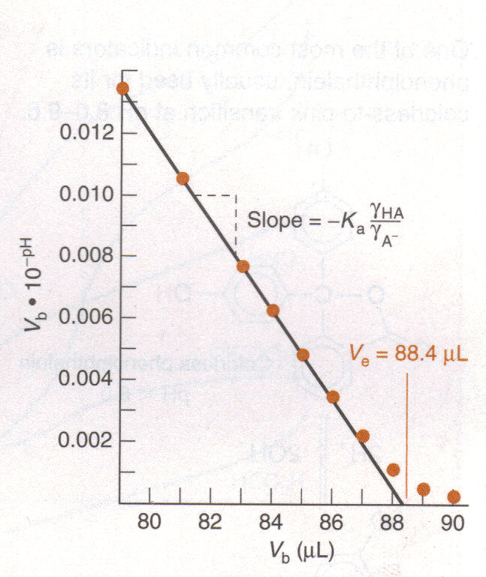
Additionally, you will employ activity correction in your calculation of K_{a} in this experiment. You will do this by calculating the ionic strength (μ) of the solution and using this to determine the activity coefficient (γ) of HP⁻ and P²⁻ (see the reaction above).
Procedure:
- Dry about 1.6 grams of the acid (potassium hydrogen phthalate – KHP) at 105⁰C for 1 hour and cool it in a dessicator. 20 minutes should be sufficient time for cooling.
- Accurately weigh (i.e. using the analytical balance) out ~ 1.5 grams of the acid and dissolve it in water in a 250 mL volumetric flask. Dilute to the mark, i.e. until the bottom of the meniscus is on the top of the line and mix the solution very well.
- Calibrate your pH meter using the buffers provided as you did in experiment 2, following the instructions provided with the pH meter. If you are still unsure about the operation of the pH meter, get help from your TA. After calibration, rinse the electrode very well with distilled water and blot dry with tissue or kimwipes before placing the electrode into your solution.
- Pipet exactly 100 mL of the acid solution into a 250 mL beaker using the volumetric pipet. Add a stir bar and position the setup in a way that the stir bar does not strike the pH electrode. Make sure that the pH meter is properly immersed in the solution. Allow the electrode to equilibrate approximately 1 minute with stirring and measure and record the initial pH of the solution.
- Add 1 drop of phenolphthalein indicator and titrate the solution with standard ~ 0.1 M NaOH. It is VERY IMPORTANT THAT YOU DO NOT USE YOUR NaOH SOLUTION FROM EXPERIMENT 1. NaOH solution has been prepared and standardized for you. Be sure to record the exact molarity and the standard deviation for this solution as you will need to know these quantities later.
- Add base in 1.5 mL increments recording the volume and the pH 30 s after each addition until you are within approximately 4 mL of the theoretical equivalence point. You can determine the theoretical equivalence point since you know the mass of KHP that you dissolved in the 250 mL of water. You can calculate molarity of your KHP solution by dividing the mass of KHP by its molar mass to determine the number of moles of KHP. The molarity of the KHP solution can then be found by dividing the number of moles by the volume in L. Knowing the molarity of the acid and the base and bearing in mind that you are only using 100 mL of the base solution, you should now be able to estimate the equivalence volume.
- When you are within approximately 4 mL of the equivalence volume, add the base in 0.4 mL increments, recording the volume and pH after each addition until you are within 1 mL of the equivalence point. After that, add base 1 drop at a time, again recording volume and pH after each addition until you have passed the pink endpoint by a few tenths of a mL. Add five more 1 mL aliquots beyond the pink endpoint. Record the exact volume at which the pink color is observed.
- Construct a graph of pH vs V_{b} (volume of added base). Locate the equivalence volume (V_{e}) as the maximum point/slope from your first derivative plot or the point of zero second derivative from your second derivative plot as you did in experiment 2. Compare these endpoints with the theoretical and phenolphthalein end points.

Calculations:
- Construct a Gran plot (graph of V_{b}10^{-pH} vs. V_{b}) by using the data collected in the region of 0.9 V_{e} and V_{e}. Draw a line through the linear portion of this curve and extrapolate it to the abscissa to find V_{e}. Use this value of V_{e} in the calculations below. Compare this value with those found with phenolphthalein and the graphs of step 8 above.
- Compute the slope of the Gran plot and use the following equation
$$V_{b}⋅{\text{10}}^{−\text{pH}}=\frac{γ_{\text{HA}}}{γ_{A^{−}}}K_{a}(V_{e}−V_{b})$$
to determine the K_{a} of KHP as follows: The slope of the Gran plot = -K_{a}γ_{HP}⁻/γ_{P}²⁻. In this equation P²⁻ is the phthalate anion (as indicated in the reaction above) while HP⁻ is the monohydrogen phthalate. Because the ionic strength changes slightly as the titration proceeds, so also do the activity coefficients. Calculate the ionic strength at 0.95V_{e} and use this “average” ionic strength to find the activity coefficient.
- You can consider the OH⁻ and H⁺ concentrations to be negligible, so the only ions whose concentrations you must consider in the calculation of ionic strength are [K⁺], [Na⁺], [HP⁻] and [P²⁻]. Recall that the ionic strength is calculated as
μ = ½ ΣC_{i}z_{i}²
- In determining the activity coefficients of HP⁻ and P²⁻, you can assume a hydrated radius of 6 for both of these ions.
- From the measured slope of the Gran plot and the values of γ_{HP}⁻ and γ_{P}²⁻, calculate pKa. Then choose an experimental point near 1/3V_{e} and one near 2/3 V_{e}. Calculate the pK_{a} at each of these points using the Henderson Hasselback equation:
$$\text{pH}={\text{pK}}_{a}+\text{log}\frac{A^{−}γ_{A^{−}}}{\text{HA}γ_{\text{HA}}}$$
In this equation, A⁻ is the base (P²⁻) and the HA is the acidic form (HP⁻).
- You will need to calculate [P²⁻], [HP⁻], γ_{HP}⁻ and γ_{P}²⁻ at each point. Calculate the average pKa values from your experiment.
- You are to carry out propagation of error analysis throughout your measurements, finally reporting the absolute uncertainty in your final answer.

CHM 212
Experiment 4 Report Sheet
Determination of the K_{a} of KHP by the Gran Plot

You are to prepare the following graphs and attach them to your report:

- Titration Curve – plot pH vs. volume of titrant (NaOH) added. On this graph indicate the approximate equivalence point. Record this value on the report sheet.

- 1st derivative curve – plot the slope (ΔpH/ΔV) vs. average volume as you did in experiment 2. On this plot, indicate the equivalence volume if possible. Remember, the equivalence is the point of maximum slope. Record this value on the report sheet.

- 2nd derivative curve – plot the change in slope Δ(ΔpH/ΔV) vs. average volume as you did in experiment 2. On this plot, indicate the equivalence point. Remember, the equivalence point is the point of zero slope, i.e. when the curve crosses zero or, when d²y/dx² = 0. Record this value on the report sheet.

- Gran plot – using the equivalence volume as determined above you are to prepare your Gran plot by using the data collected between 0.9V_{e} and V_{e}. You are to plot V_{b}.10^{-pH} vs. V_{b}, where V_{b} is the volume of base added and the pH is the pH determined from the pH meter at that added volume of base. Refer to the plot in the lab instructions.

Other important instructions:

- on your Gran plot you are to draw a line through the linear portion of the curve and extrapolate to the abscissa (x-axis) to find V_{e}. Refer to the plot in the lab instructions if you need clarification

- use this value in the calculations as instructed on page 3 of the lab instruction

- attach your calculations to this report

Below is an example of how ionic strength coefficient is calculated:

Example: find γ_{HP}⁻ and γ_{P}²⁻ at 0.95 V_{e} in the titration of 100.0 mL of 0.0200 M KHP with 0.100 M NaOH.

V_{e} = 20.0 mL, so 0.95 V_{e} = 19.0 mL. [H⁺] and [OH⁻] are negligible so only need to consider [K⁺], [Na⁺], [HP⁻] and [P²⁻]. These are calculated as:
$$\begin{aligned}[K^{+}]=\left(\frac{\text{100}\text{mL}}{\text{119}\text{mL}}\right)(0\text{.}\text{0200}M)=0\text{.}\text{0168}M \\ [{\text{Na}}^{+}]=\left(\frac{\text{19}\text{mL}}{\text{119}\text{mL}}\right)(0\text{.}\text{100}M)=0\text{.}\text{0160}M \\ [{\text{HP}}^{−}]=0\text{.}\text{050}\left(\frac{\text{100}\text{mL}}{\text{119}\text{mL}}\right)(0\text{.}\text{0200}M)=0\text{.}\text{00084}M \\ [P^{2−}]=0\text{.}\text{95}\left(\frac{\text{100}\text{mL}}{\text{119}\text{mL}}\right)(0\text{.}\text{0200}M)=0\text{.}\text{0160}M \\ μ=12{Σc}_{i}z_{i}^{2}\end{aligned}$$
μ = ½ [(0.0168)(1)² + (0.0160)(1)² + (0.0160)(-2)² + (0.00084)(-1)²] = 0.0488 M

Using this value of ionic strength and the given ionic radii or 6 for both HP⁻ and P²⁻ you can now determine the ionic strength using the table of activity coefficients from your textbook.

Due: Thursday, 25th October, 2007
Name:_________________
Grade:_________________
Experiment 4 Report Sheet
Determination of the K_{a} of KHP by the Gran Plot
Molarity of NaOH: ________mol/L
Equiv. volume from titration curve: ________mL
Equiv. volume from 1st derivative: ________mL
Equiv. volume from 2nd derivative: ________mL
Equiv. volume from Gran plot: ________mL

Slope of Gran plot (dy/dx): ________

Recall, the slope of the Gran plot = -K_{a}(γ_{HP}⁻/γ_{P}²⁻), therefore you will need to calculate the average ionic strength of the solution at 0.95V_{e} and use this value of ionic strength to find the activity coefficients.

Ionic strength at 0.95V_{e}: ________mol/L (show calculation)
Recall: μ = ½ ΣC_{i}z_{i}²

γ_{HP-}: ________ (show calculations)
γ_{P}²⁻: ________ (show calculations)
K_{a} of KHP: ________ (show calculations)
pKa: ________ (show calculations)

Using the Henderson-Hassebach equation as instructed in the lab instructions calculate the pKa at 1/3 and 2/3 V_{e}
pK_{a} at 1/3 V_{e} by H-H equation: ________ (show calculations)
pK_{a} at 2/3 V_{e} by H-H equation: ________ (show calculations)
average pK_{a}: ________ (show calculations)

